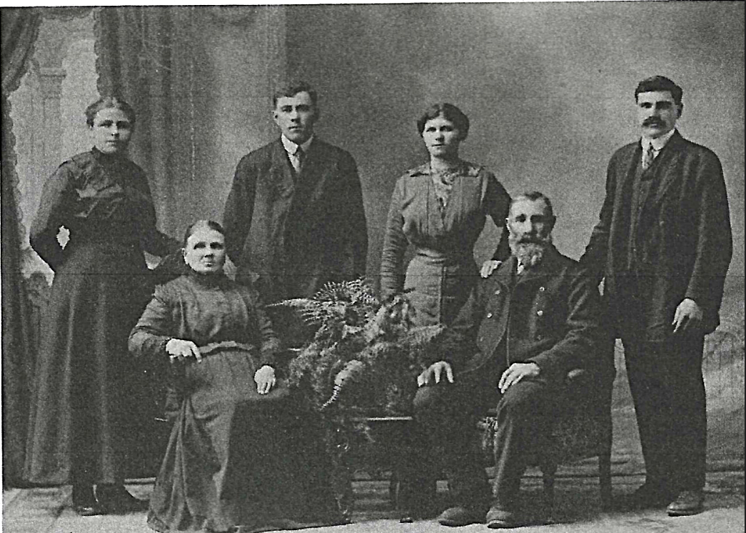

Front Row: Friedrich (1854-1939) and Wilhelmina (1853-1945) Mielke (nee Kreuger)

Back Row: Adolph and Wilhelmina Biesenthal (born Mielke), Gustav and Wilhelmina Mielke (born Koops)